**Session: Introduction to Databases**

**Name: Ahan Jain**

**EmpID: 8202**

**1. Problem Statement: There can be multiple customers, who can place multiple orders on the site. Now a sales person can handle these orders will distribute into multiple sales persons. One order will be assigned to one salesperson only. So a sales person can have multiple orders of multiple customers. Create a Database.**

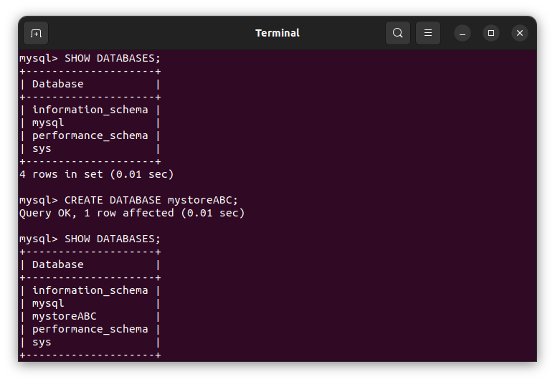

**2. Design Schema.**

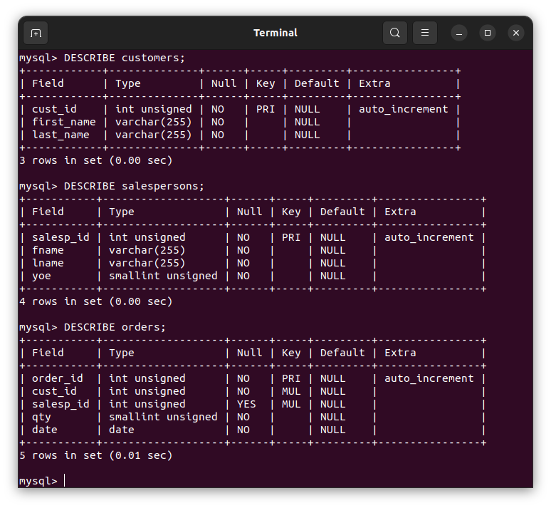

**3. Create tables.**

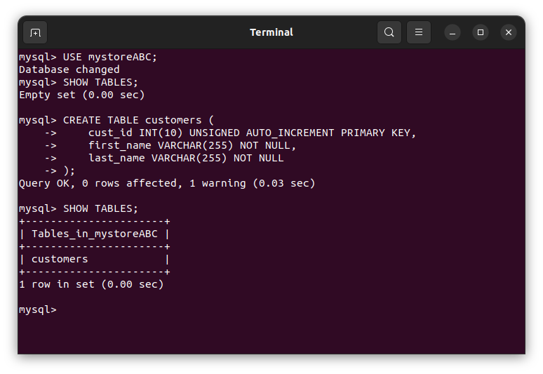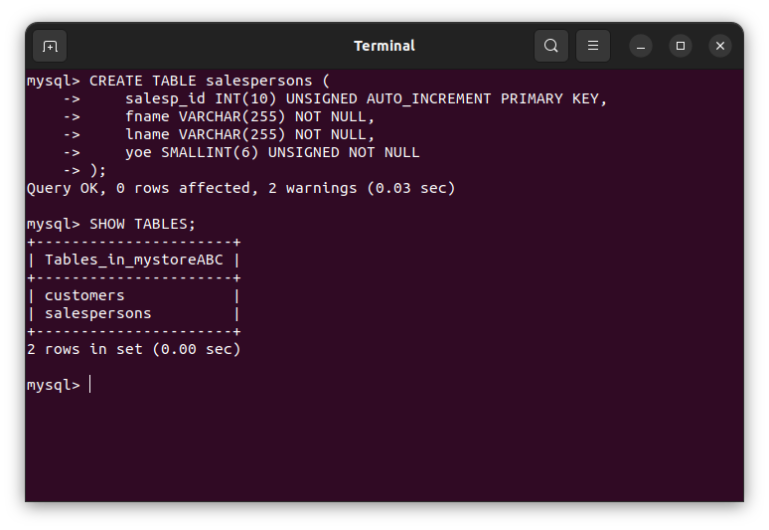

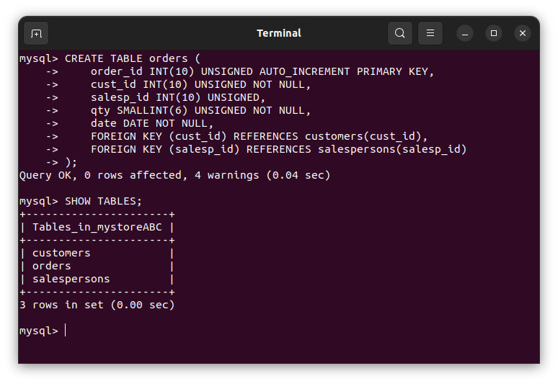

**4. Insert sample data.**

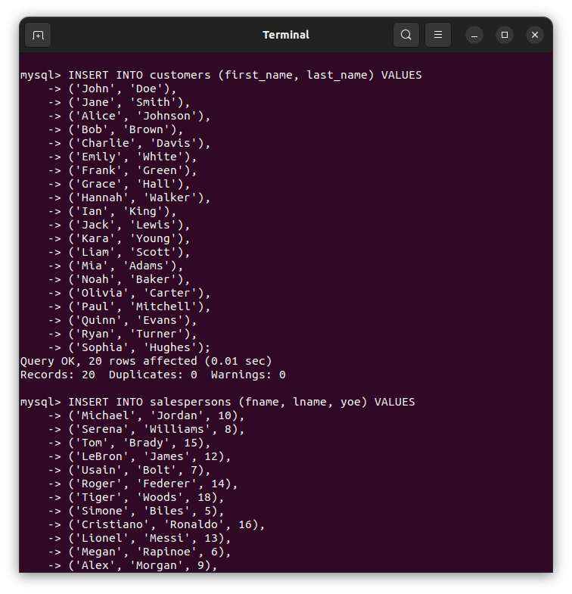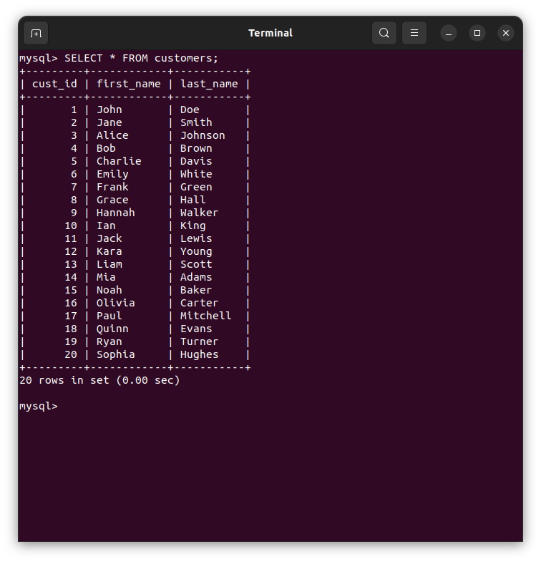

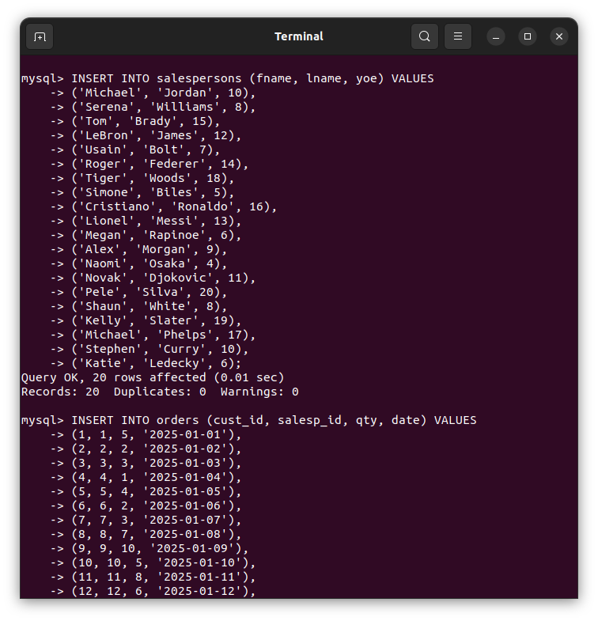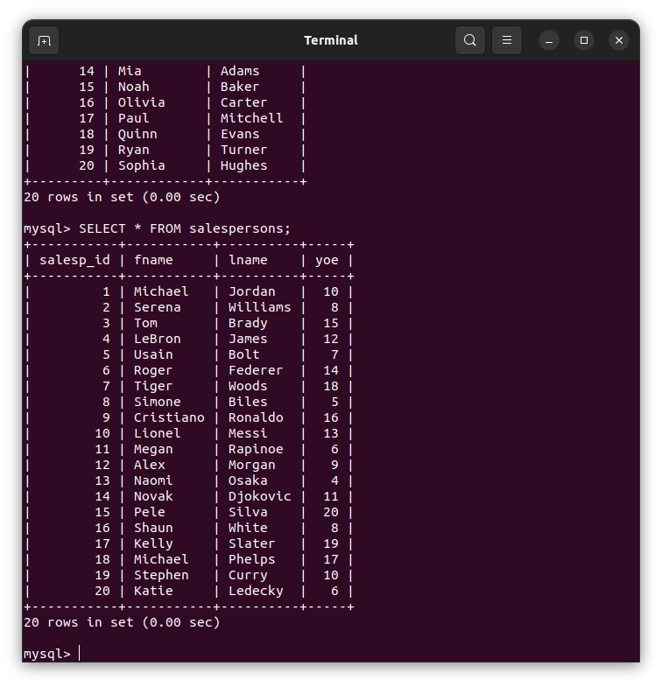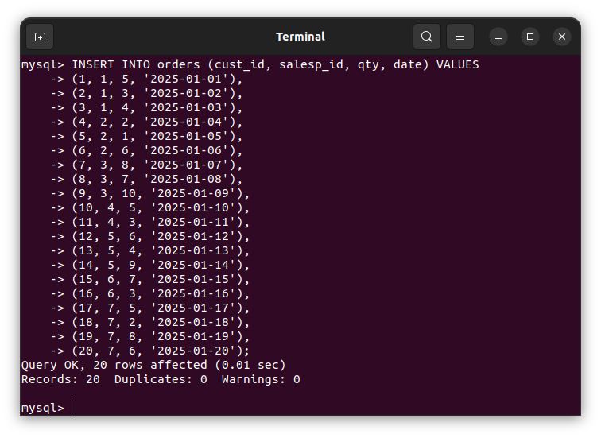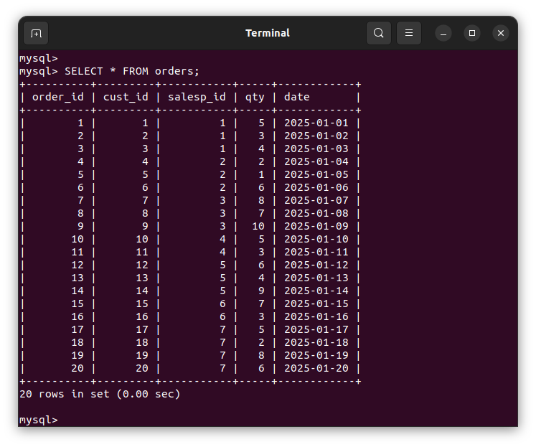

**5. Find the sales person have multiple orders.**

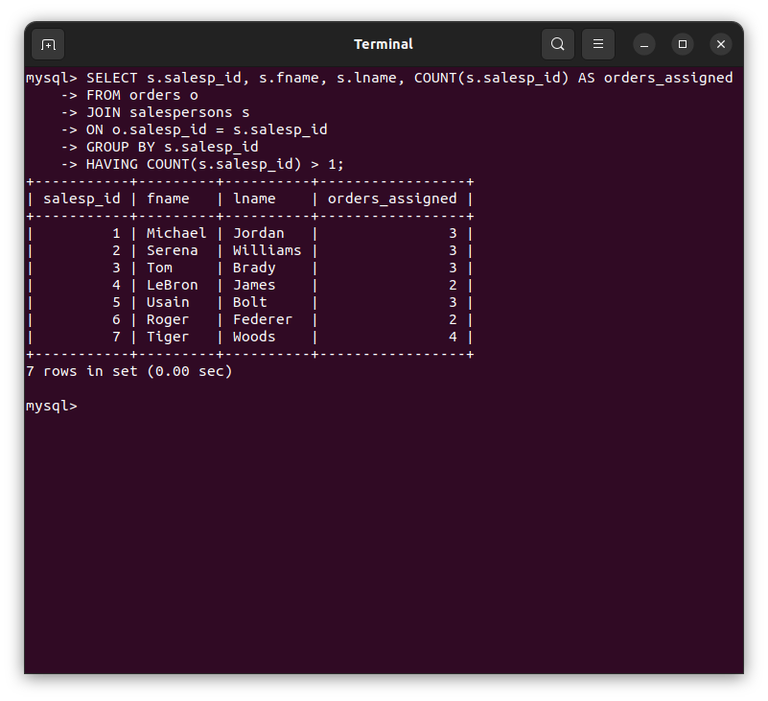

**6. Find the all sales person details along with order details.**

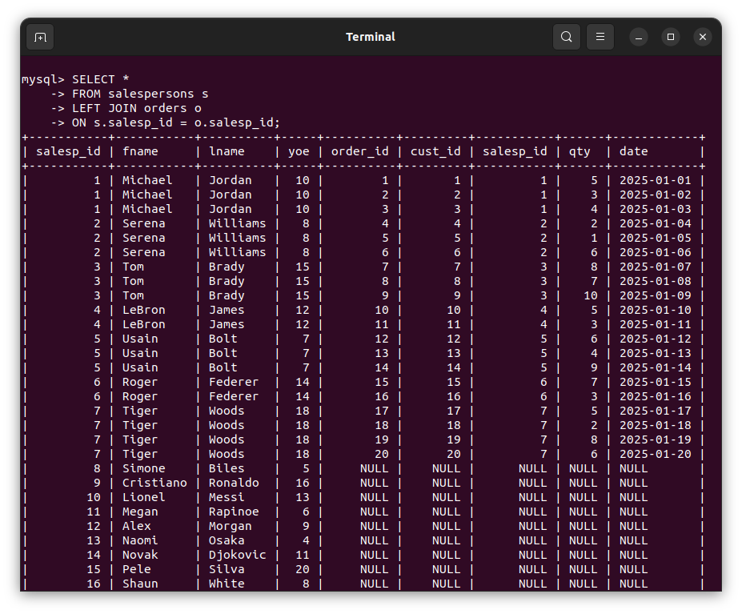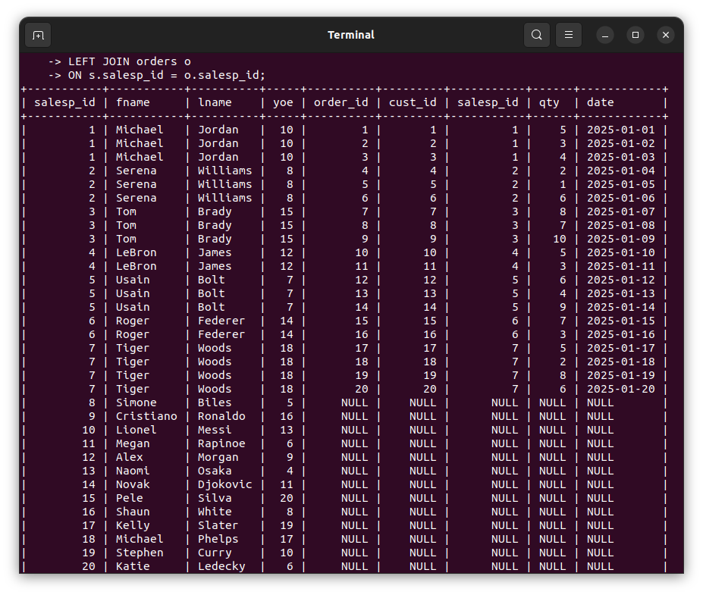

**7. Create index.**

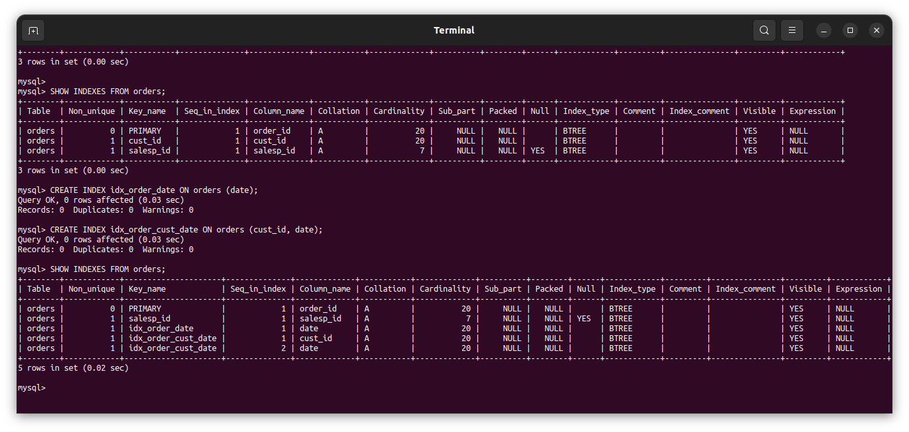

**8. How to show index on a table.**

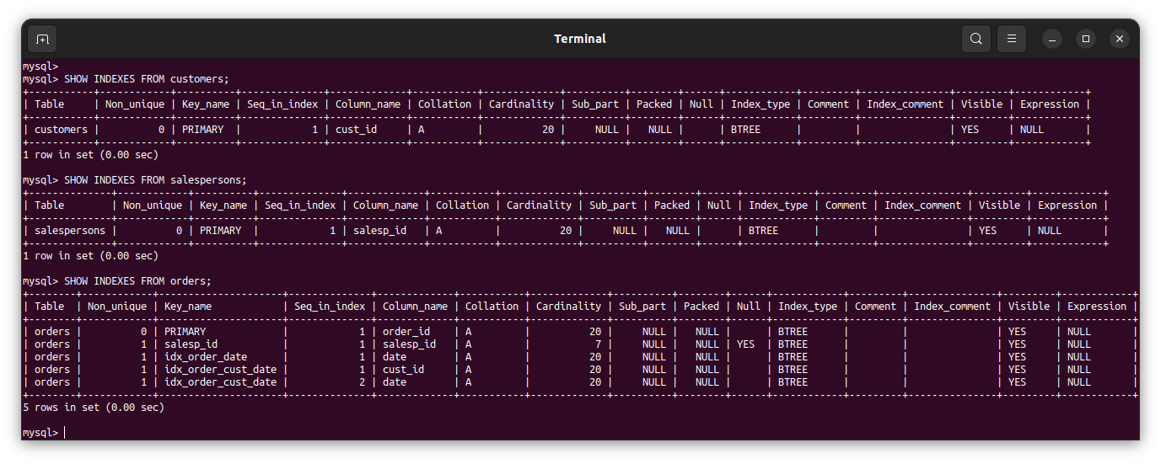

**9. Find the order number, sale person name, along with the customer to whom that order belongs to.**

